Two-third Use Multicloud for Data Protection - Dropbox and OneDrive are the Most Popular Cloud Storages

Augsburg, Germany on Juli 29th, 2019: Encryption software provider Boxcryptor presents the results of its customer survey

For the first time, the encryption software provider Boxcryptor carried out a large-scale customer survey in spring 2019. The results now provide precise information about the behavior of security-conscious cloud users. One finding: data protection awareness does not rule out the use of large US cloud storage providers – thanks to encryption.

"Our customer survey shows that over the years a personal recommendation has become increasingly important when it comes to choosing to encrypt data," said Andrea Pfundmeier, CEO of Boxcryptor. "Our most important selling point, however, remains the large number of cloud storage vendors we support. This will remain one of our priorities in the future," adds Robert Freudenreich, CTO of Boxcryptor. From now on, the founding team will have regular surveys carried out.
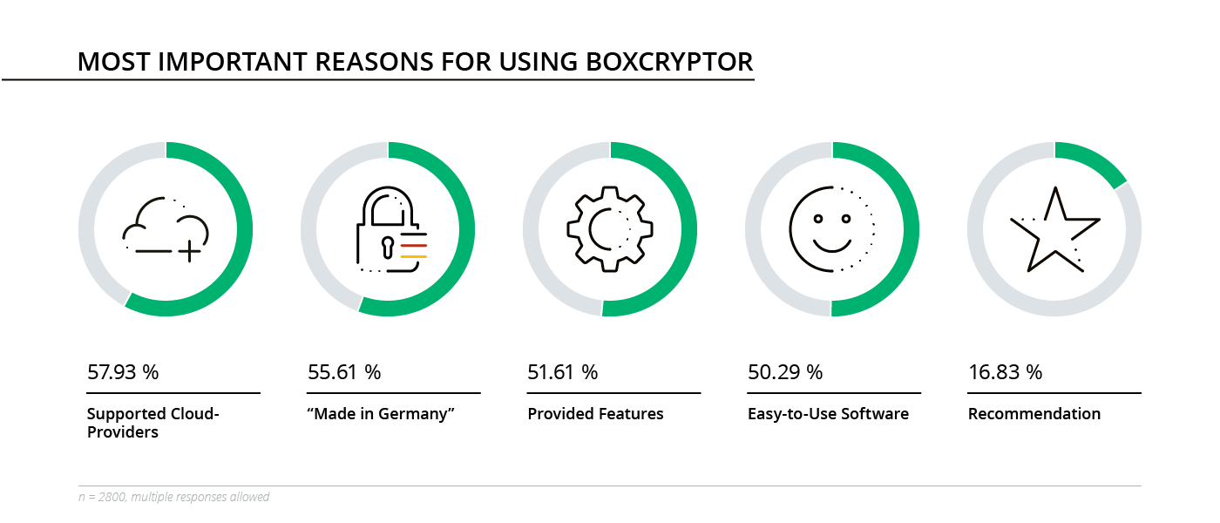
3,000 users of the Boxcryptor encryption software took part in the survey. The survey was published in German, English and Russian. The respondents came from 71 countries.

The most important results at a glance:
- Two-thirds of respondents use more than one cloud to store their encrypted data.
- Dropbox, OneDrive and Google Drive are the most popular cloud stores.
- Personal recommendations are playing an increasing role in the installation of encryption software.
All results in detail, graphics and statements of our users can be found on our website at www.boxcryptor.com/blog/post/boxcryptor-customer-survey-2019/.

Strengthened with these insights, Boxcryptor will be present at this year's it-sa again. At the IT-Security fair in Nuremberg (8. - 10. October 2019) our security experts will be available for further questions on cloud encryption at booth 10.0 - 524.

Your contact person for further inquiries:
Secomba GmbH www.boxcryptor.com
Lisa Figas tel: +49 (0821) 907 861 57
Werner-von-Siemens-Str. 6 fax: +49 (0821) 907 861 59
86159 Augsburg mail: lf@secomba.com

Secomba GmbH is the German company that develops Boxcryptor, a cloud-optimized encryption solution for businesses as well as private users. The company was founded by Andrea Pfundmeier and Robert Freudenreich in 2011. Boxcryptor’s integrated zero knowledge and end-to-end encryption protects their customer’s data from unauthorized access, and therefore enables the secure use of many cloud storages. Boxcryptor is used by leading companies in Europe and worldwide for secure collaboration in the cloud. Find out more on www.boxcryptor.com.

